Graden Benton
Final Project
COM 486
12/13/22
NIL: Leveling the Playing Field

15 months after the legalization of NIL it has presented an opportunity to give athletes the power to earn compensation. This has changed the aspect of recruiting athletes at all levels, including Washington State University.

“We are past the point of saying if it is good or bad. The recruiting endorsements with NIL have been going on for years and has evolved college athletics. Things may seem to be out of control with the transfer portal, but I do not see it slowing down anytime soon,” said Pete Nakos, NIL reporter for On3 Sports.

Last Monday, the first window of the transfer portal became available to college football athletes. According to CBS sports, more than 3,000 FBS players entered last year’s portal cycle.
This year will be the biggest number yet with NIL expanding across the nation.

Despite some backlash, Nakos said NIL is good for college sports, and the combination with the transfer portal has given power to the student athletes. Nakos also said the talent disparity will lessen because of NIL.

“I think the smaller schools can collectively offer lucrative NIL opportunities on their campus. We are headed to the days where a highly touted recruit will look at his options and see if they can be the most valuable athlete at a smaller school, rather than being the 10th best athlete at the regular powerhouse schools,” said Nakos.

Head basketball manager Ethan Kramer said the transfer portal has been an essential part of the Washington State basketball program, even though they are one of the smaller power five teams.

“We have had a number of transfers come here and impact our play right away. This has helped our record, which ultimately helps recruiting and getting good players to play here,” said Kramer.

Kramer says in the last three years there has been eight transfers from other schools to play for the cougs and have recruited big time recruits along the way such as former coug Efe Abogidi, and current sophomore Mouhamed Gueye.

“The addition of NIL and the transfer portal has transformed college basketball recruiting. NIL has changed the game for smaller schools like WSU, and we can expand on the recent success we have had before NIL” said Kramer.

To give these athletes NIL deals, many alumni of these universities create these collective groups. For Washington State they have the Cougar Collective.

Executive director of Cougar Collective, Zach Thornton said his staff is made up of WSU alumni that volunteer their time and want to give all Washington State athletes the opportunity to earn NIL deals.

“We are the main collective at Washington State. There are a bunch of national marketplaces that have turned themselves into job posting boards, where companies can sign up and post a job for an athlete,” said Thornton. “We acquire contributions, sponsorships, and in turn create NIL opportunities through those sponsorships. Our collective is making big pushes to ultimately help all of our 450 student athletes here at Washington State.”

These collectives are not affiliated with the universities, as they are an entity that acts as a passthrough to allow fans, businesses, and charities to connect with them and their athletes.

“It is a tricky situation. The state of Washington has strict rules for NIL, but they are not officially ruling. We have to follow a Washington State ethics law, that prohibits state employee’s ineligible to execute deals. Their role can only be on education based,” said Thornton.

Universities are prohibited to release the names of the athletes who want to participate in the collective. The University has an entire NIL team that Thornton works with almost weekly.

“It is frustrating at times, but it is no one’s fault. We have to walk a fine line, but we are updating compliance and the legality of everything we are doing. We are very transparent with the University,” said Thornton.

Cougar Collective has hosted events with the Washington State football, volleyball, soccer, and most recently the baseball team. Five baseball players were able to participate in an event called “A place to call home”, in Liberty Lake, Washington.

Sophomore Elijah Hainline said this was his first NIL event. Hainline and his teammates were able to be sign baseballs, take pictures, and were eligible to be paid NIL money.

“The event was an amazing opportunity to be a part of the community and have an experience that could change kids’ lives. For me it’s not all about the money. I want to be able to represent something and create something great. It showed how much cougs support cougs,” said Hainline.

Hainline said the collective and NIL is an opportunity for not just athletes from football and basketball to take advantage of their image and marketability.

“I think every athlete should have equal opportunities based on the school you are at. If you are going to make money for your name, why not set yourself up the best for your future. It is only the beginning for student athletes to be able to have the freedom like professionals do. We have been restricted for far too long,” said Hainline.
Sources:
Elijah Hainline: Email: Elijah.hainline@wsu.edu
Ethan Kramer: Cell-509-828-5309
Pete Nakos: Cell-603-722-8774
Zach Thornton: Cell-253-459-9672

Graden Benton
Aggregate Story #3
COM 486
10/25/22

Student Enrollment Decline Trend Does Not Affect the University of Idaho
University of Idaho announced last week the largest Freshman enrollment in the school’s history.
Vice Provost of the University of Idaho, Dean Kahler says the adjustments the university had made since 2019 have been the huge difference, and he plans to see even more growth in the future.
“We have the enrollment plan mapped out to 2025 and we have our goal set. There is no slowing down at this point,” said Kahler.
Kahler says the university had 1665 incoming Freshman last year and topped that by 280 students for 1951 Freshman this fall. He says some incoming freshman even had to stay at the Fairbridge Inn in Moscow, because the residence halls were full.
“Our College of Business had a 21% increase, our Engineering program saw 34% increase, and our College of Letter Arts and Social Science increased by almost 20%,” said Kahler. “Those were our three top performers percentage wise, but we are seeing the last two years every single college performing very well.”
University of Idaho ranks as the second-best value public school in the U.S. for the third year in a row. They only trail University of North Carolina for the top position in the nation.
Kahler says it is not just being one of the cheaper schools that makes them one of the best public value universities in the nation.
“The U.S. News and World Report defines the best value as a combination of high caliber academic programs, what the student earns in their degree, and what they are capable to earn once they get out into the market,” said Kahler. “Here at University of Idaho, we are able to match all of those requirements.”
The university also saw their overall non-resident student enrollment increase.
University of Idaho Accounting major, Scott Utzman says the impact of the Western Undergraduate Exchange (WUE) program was one of the deciding factors in choosing to attend the University.
“Even though I live in Pullman, with the WUE I am able to have around the same tuition rate per semester compared to WSU,” said Utzman. “This allows me to put the money aside and decide on the program that I thought would benefit me the most.”
According to the University of Idaho Student Financial Aid Services, a WUE student tuition rate is $11,486, while Washington State University in-state tuition rate is $11,266.
University of Idaho is one of 160 colleges in the western states to have the WUE. Washington State University is not one of those participating colleges involved in this program.
“I have talked to people that lived outside of the state of Washington that go to Idaho and say that if WSU had the WUE then they would have considered it more when they were applying to schools,” said Utzman.
While across the nation many universities have seen a dip in enrollment and retention rate, University of Idaho has a trajectory that is pointing upwards

Sources:
Vice Provost Dean Kahler: dkahler@uidaho.edu
University of Idaho student, Scott Utzman: 206-596-7653
http://www.futurestars.org/blog/what-western-undergraduate-exchange
https://www.uidaho.edu/financial-aid/cost-of-attendance
https://admission.wsu.edu/tuition-costs/tuition-break-down/
https://localnews8.com/news/education/2022/10/22/largest-u-of-i-freshman-class-in-recorded-history-contributes-to-increased-enrollment/

Graden Benton
In-Depth News Story
COM 486
10/6/22

Knocking on The Door: Fall Preview-Washington State Baseball
Washington State Baseball looks to make its first postseason appearance in 13 seasons. This fall the team shows all the signs to finally break through that door.
Following back-to-back plus .500% winning seasons since the regional teams of 2009-2010, the Cougars seem determined to end their postseason streak.
“Following the disappointment of the past two years we are putting our head down this fall, and we want nothing more but to play competitive baseball in the postseason,” said Junior Shortstop Kyle Russel.
Head Coach Brian Green heads into his fourth year as the head skipper. He tallies an overall record of 62-56, and a Pac-12 conference record of 25-35. This year, Green adds new hitting coach and recruiting coordinator Jake Valentine to his staff.
According to D1Baseball, they list Valentine as the 17th best assistant hire in the country. He previously held the same role at University of Portland for seven seasons as one of the top recruiters in the West Coast.
“The opportunity to work in the Pac-12 is hard to pass up, and I found out really quickly talking to Coach Green and the staff that I can be on board with their beliefs and their systems. This program is about to pop and I really wanted to be a part of it,” said Valentine.
On Wednesday, the Cougars played their first of three Exhibition games this fall. They played two seven-inning games against a travel ball team from Canada, The Okotoks Dawgs. They were victorious in both with scores of 13-0, and 11-0.
“Playing outside competition really takes the control environment of a practice and shows us what we really got. The walk/strikeout ratio was great, and our pitchers struck out 27 hitters against one walk. Obviously, it is going to be harder in the spring, but if we continue the execution, we should be in great shape,” said Valentine.
The Cougars return 19 players from last year’s team. With 26 new players, Senior All Pac-12 1st Baseman, Jacob McKeon says this year’s group mojo is the biggest difference from last year’s team.
“Whenever you have a big roster turnover, you want to create a team environment as quick as you can. I think the willingness to win and compete their butts off for each other
is the biggest difference from last year,” said McKeon.
McKeon has been the heart of the lineup for the Cougs the past two years. With a career batting average of .348, he hopes to add power to his arsenal this upcoming season.
“I think my role in this lineup will be to drive runs in and hit bombs. It is something I have been working on this offseason. I think it is the next step for not only me, but for our team. We need to be able to put the ball out of the park more,” said McKeon.
The Cougs have hit 76 home runs the past two seasons, which rank ninth in the conference of out the 11 teams, (University of Colorado does not carry a baseball team). They do however return their top three Home Run hitters in McKeon (7), Junior Outfielder, Bryce Matthews (6), and Senior Outfielder, Nate Swarts (4).
“The hitters this year are more well-rounded. We have a better Left/Right batter ratio and have been improving on our swings in order to get more balls out of the yard and drive in more runs,” said Valentine.
On the mound, the Cougs return six of their top seven strike throwers from last year. This includes multiple time Pac-12 pitcher of the week, Senior, Grant Taylor, and Senior relievers Chase Grillo, Caeden Kaelber, and Cam Liss.
The trio combined for the bulk of the innings out of the bullpen and look to improve upon their 5.17 ERA last year. The biggest key on the mound, however, could be the comeback of Senior Pitcher Dakota Hawkins.
“Last year was a little disappointing for me. I was not able to be out there on the field with my guys, but I am looking forward to this season, and feel better than ever,” said Hawkins.
Hawkins had an injury-plagued 2022 season but was dominant when on the bump. He appeared in 10 games, a record of 4-0, with 25 strikeouts against four walks in 20.2 innings. His fastball was up to 94 MPH on Wednesday against the Dawgs.
Hawkins says their depth has improved since last year. He says a couple of incoming guys will make an instant impact and help their bullpen this year:
- Junior RHP, Shane Spencer (Central Arizona College)
- Freshman RHP, Ryan Orr (Tumwater High School)
- Junior RHP, Connor Wilford (Saddleback College)
On the field, Valentine says their defense could be their strongest suit with six returning starters, and notable transfers:
- Junior Outfielder, Jonah Advincula (Redlands University)
- Senior Infielder, Jacob Harvey (Cal State Fullerton),
- Junior Infielder, Sam Brown (Portland)
- Sophomore Infielder, Cam Magee (Arizona State)
“Combining all three attributes instead of only having one in the top of the Pac-12 is going to allow us past that threshold of over 30-35 wins, and bust down that door to make a regional,” Valentine said.
McKeon says this team has a chip on their shoulder, and it will end the 13-year postseason streak. He says their attitude will be the biggest difference.
“We are thought of the underdog team, but we have to embrace that Cougs vs. Everybody mentality in order to put Cougar Baseball on the map. When we make it to a regional, to the community of Cougs it will be enormous. It will show how much we care to put on this jersey for them every day,” said McKeon.
Washington State continues their Fall season with two more exhibition games this season. They host Gonzaga at home on Sunday, October 16th at 12:15 PM, before traveling to California to take on Cal State Fullerton Saturday, October 22nd to wrap up the Fall season.

Sources:
https://d1baseball.com/
https://pac-12.com/sport/baseball
https://wsucougars.com/sports/baseball?path=baseball
Kyle Russel: 253-753-6413
Jacob McKeon: 480-745-6748
Dakota Hawkins: 306-269-0244
Jake Valentine: 306-606-3451
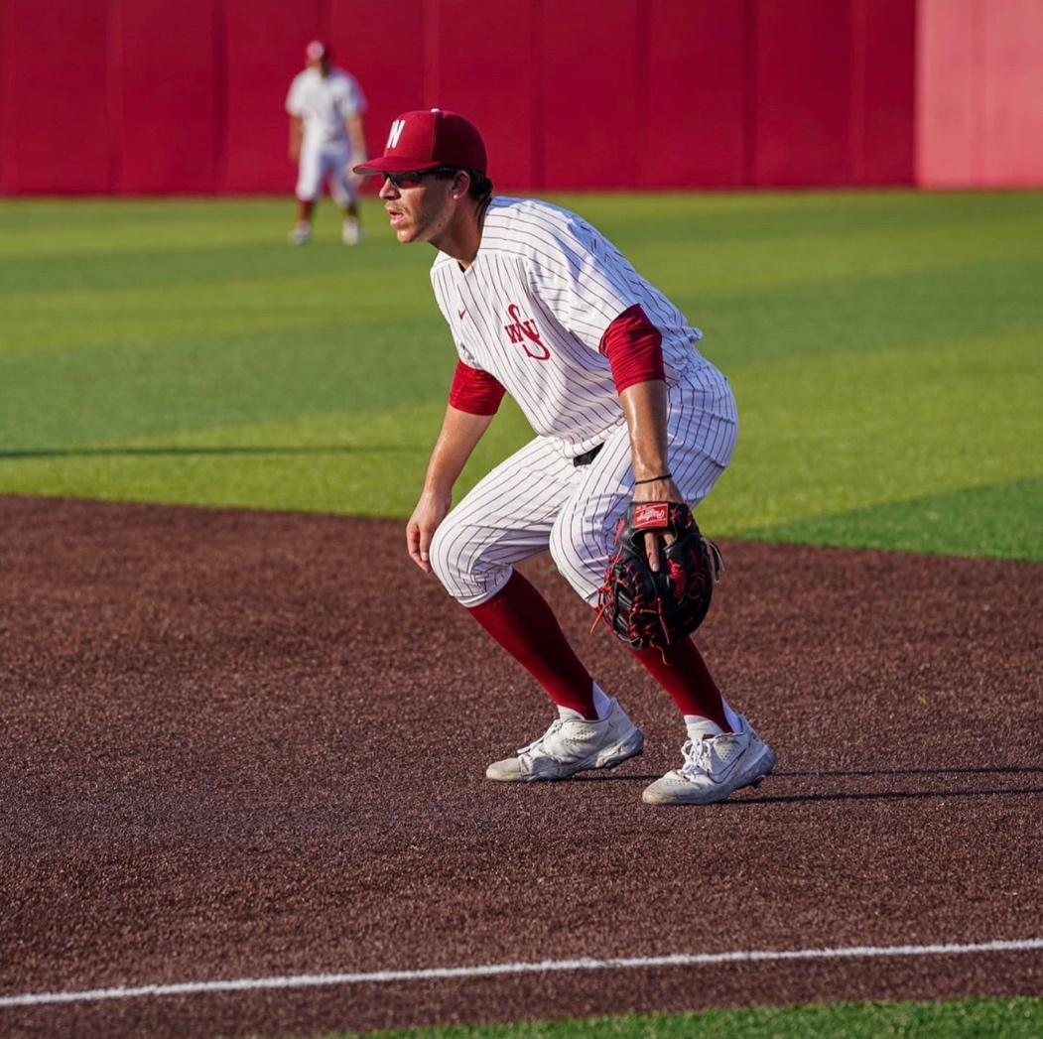
Above: Jacob McKeon
Picture from WSU Baseball

